BUY ONE MORE

Your help where it’s needed!
Buy durable products in [supermarket]
Noodles Rice Flour Cereals
Sugar Canned food
dumplings Marmelade

Give it to Rotaractors
at the supermarkets exit

We forward your donation to
[organization] in [city]
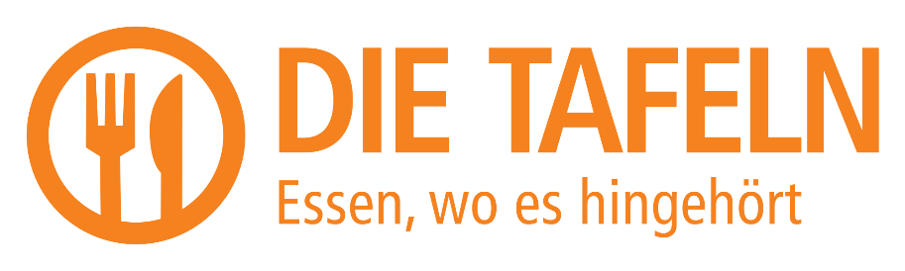

www.bad-hersfeld.rotaract.de

BUY ONE MORE

Your help where it’s needed!
Buy durable products in [supermarket]
Noodles Rice Flour Cereals
Sugar Canned food
dumplings Marmelade

Give it to Rotaractors
at the supermarkets exit

We forward your donation to
[organization] in [city]

www.bad-hersfeld.rotaract.de

BUY ONE MORE

Your help where it’s needed!
Buy durable products in [supermarket]
Noodles Rice Flour Cereals
Sugar Canned food
dumplings Marmelade

Give it to Rotaractors
at the supermarkets exit

We forward your donation to
[organization] in [city]

www.bad-hersfeld.rotaract.de

BUY ONE MORE

Your help where it’s needed!
Buy durable products in [supermarket]
Noodles Rice Flour Cereals
Sugar Canned food
dumplings Marmelade

Give it to Rotaractors
at the supermarkets exit

We forward your donation to
[organization] in [city]

www.bad-hersfeld.rotaract.de

