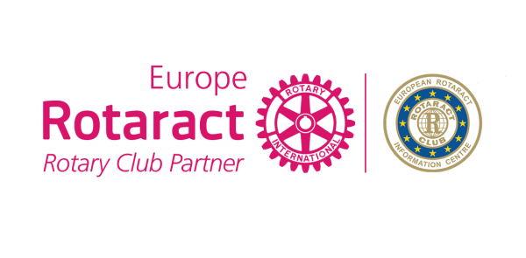
Application for
Twin Club Award
2017-2018

Twin Club 1:
Rotaract Club
District
Country
Contact Person
Email

Twin Club 2:
Rotaract Club
District
Country
Contact Person
Email

Twinning Date

How did you find each other?

Tell the story of your twinning…

What were your goals of twinning with each other?

Which Rotary’s 6 areas of focus does your project target? And which Rotaract Europe MDIO 4 themes does your project target?

Forecast number of hours spent on voluntary work

What is the impact of the project to the society and community?

Describe your joint activity:
Project Title | Type of project | Description

Website link (or facebook page)
Digital Communication (shares,likes, comments)
Media Coverage (newsletters, youtube, blogs, etc)
Did you share your Project in ERIC Newsletter or under 4 themes, Discussion Groups to maximize the success?

Questions…

Please write more than a “Yes” or “No” answer.
We want to understand your connection!

Did you organize friendship and/or cultural exchange?

Did you exchange project ideas and/or Club program ideas?

Have you had video conferences or held web based Club meetings together?

Do you plan to remain twinned?

Why do you think your Twinning is worthy of a Twin Club Award? And if you win the money price, what will you do with it?

What else do you want us to know before we start evaluating?

You can contact Rotaract Europe MDIO Social Office in case of any questions. Once you complete the application form please send it to E.R.I.C. Social Committee – social@rotaracteurope.eu.

Please send picture album, documents and even your project video from the projects you did together in a separate folder.

Deadline: February 25th, 2018

IF you aren’t attending EUCO Antwerp, your CR will go to the stage to take your award

Bank details:

We ask you for the bank details in order to facilitate and make faster the bank transfer in case you win. This info will not be shared with anyone else besides the Social Committee and the E.R.I.C. Treasurer.

Twin Club 1:
Full name of bank account owner
Postal address of bank account owner
Country
IBAN
BIC/SWIFT
Name of the bank
Postal address of the bank (only needed if you are in a non swift country)

Twin Club 2:
Full name of bank account owner
Postal address of bank account owner
Country
IBAN
BIC/SWIFT
Name of the bank
Postal address of the bank (only needed if you are in a non swift country)

