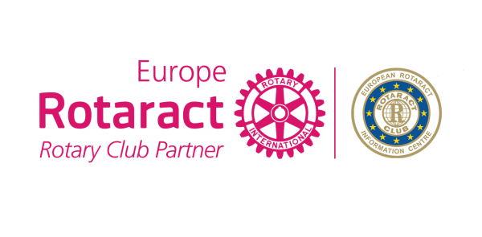
Application for
Rotary-Rotaract Collaboration Award
2017-2018

Rotaract Club
District/Country
Rotary Club
District/Country
Number of Club members
Contact Person
Email

Project name

Start date |  | Finish date

Project Goals and Objectives

Location (city, country)

Effectiveness of the Project (How was your project affected the society?

Budget (EUR)

Overview (Description of the project)

Which Rotary’s 6 areas of focus does your project target?

How you ever organized a happy hour or an event as being Rotary and Rotaract together in order to build a healtier relationship?

How many people benefited from that project?

Forecast number of hours spent on voluntary work as being Rotaract and Rotary together

Project Results

Website link (or facebook page)
Digital Communication (shares,likes, comments)
Media Coverage (newsletters, youtube, blogs, etc)
Did you share your Project in ERIC Newsletter or under 4 themes, Discussion Groups to maximize the success?

Participation rate of Club members (%)
Number of Rotary and Rotaract members involved in the project

Questions…

Please write more than a “Yes” or “No” answer.
We want to understand your project!

Have you involved any other Rotaract or Rotary Clubs (in your City, Country, District, other countries)?

Have you ever invited a rotary member to your meeting as a speaker and asked him to make a presentation?

The mutual meetings number that you realized as being Rotary and Rotaract together(please even share the meeting dates and names or numbers of the Rotarians who attended the meeting)

Have you ever released a mutual event together to raise money for service project (please specify the amount)?

Does your Club and Rotary Club plan to continue/repeat this Project in future? Can it be transferred to other countries?

What is the projects’ contribution to the image of Rotary and Rotaract in public?

What else do you want us to know before we start evaluating?

You can contact Rotaract Europe MDIO Social Office in case of any questions.
Once you complete the application form please send it to E.R.I.C. Social Committee – social@rotaracteurope.eu.
Please send picture album, documents and even your project video from the projects you did together in a separate folder.

Deadline: February 25th, 2018

IF you aren’t attending EUCO Antwerp, your CR will go to the stage to take your award

