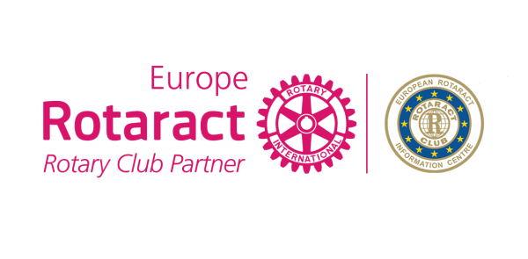
Application for
Best European Service Project Award
2017-2018

Rotaract Club
District/Country
Country
Number of Club members
Contact Person
Email

Project name

Start date |  | Finish date

Overview (Description of the project) (limit 250 words)
Project Goals and Objectives and which Rotaract Europe MDIO 4 themes does your project align with? Which Rotary’s 6 areas of focus does your project target?
(limit 250 words)
Location of the project (city, country)
Describe the Target Group and the difficulties/solutions the target group has. (limit 250 words)
Budget (EUR)
Tell us a brief story about how the project positively benefited the community or a person. (limit 250 words)

Website link (or facebook page)
Digital Communication (shares, likes, comments)
Media Coverage (newsletters, youtube, blogs, etc)
Did you share your Project in ERIC Newsletter or under 4 themes, Discussion Groups to maximize the success?

Quantifiable results
Number of members/clubs/districts/countries involved in the project (please list the clubs, districts and countries)
Forecasted number of hours spent on the project
What is the impact of the project to the society and community?
How were you able to innovate throughout the project? Is this the first time this project has been implemented locally and globally?
Have you involved any other Rotaract Clubs (in your City, Country, District, other countries)?
How did you engage Rotarians and local experts, partners, sponsors and organizations? (limit 250 words)
How were your projects objectives achieved? Please include how you ensured a positive and sustainable impact to all involved. (limit 250 words)

Does your Club plan to continue/repeat this Project in future? Can it be transferred to other countries?

Why do you think this project is the Best European Service Project?
Please provide a forecasted budget of how the award money will be spent if your project wins.

What else do you want us to know before we start evaluating?

You can contact Rotaract Europe MDIO Social Office in case of any questions. Once you complete the application form please send it to E.R.I.C. Social Committee – social@rotaracteurope.eu.
Please send picture album, documents and even your project video from the projects you did together in a separate folder.

Deadline: February 25th, 2018

IF you aren’t attending EUCO Antwerp, your CR will go to the stage to take your award

