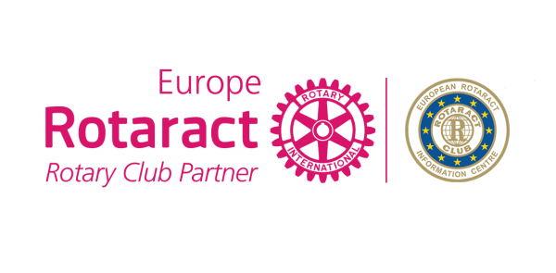
Application for
4 Themes Project
2017-2018

Rotaract Club
District/Country
Country
Number of Club members
Contact Person
Email

Project name

Start date |  | Finish date

Project Goals and Objectives

Which Rotaract Europe MDIO 4 themes does your project target?

Describe the Target Group and the difficulties/solutions the target group has

Budget (EUR)

Overview (Description of the project)

How did you raise awareness about diseases and support health-related organizations?

How did you provide medical examinations to those without medical access?

How did you celebrate and strengthen peace and create international friendship and understanding through the network of Rotaract?

How did you strengthen the quality of education, contribute towards economic development?

How did you improve the standards of living around Europe and the world?

How did you identify an environmental issue in your local community, raise awareness and improve the overall situation for generations to come?

How did you diagnose and develop treatment of the diseases?

Please Describe what your project solved and objectives achieved

Forecast number of hours spent on voluntary work

Does your Club plan to continue/repeat this Project in future? Can it be transferred to other countries?

What is the impact of the project to the society and community?

How many people benefited from that project?

How were you able to innovate throughout the project?

Project Results

Website link (or facebook page)
Digital Communication (shares,likes, comments)
Media Coverage (newsletters, youtube, blogs, etc)
Did you share your Project in ERIC Newsletter or under 4 themes, Discussion Groups to maximize the success?

Participation rate of Club members (%)
Number of members involved in the project

What else do you want us to know before we start evaluating?

You can contact Rotaract Europe MDIO Social Office in case of any questions. Once you complete the application form please send it to E.R.I.C. Social Committee – social@rotaracteurope.eu.

Please send picture album, documents and even your project video from the projects you did together in a separate folder.

Deadline: February 25th, 2018

IF you aren’t attending EUCO Antwerp, your CR will go to the stage to take your award

